1. create one new item in Jenkins

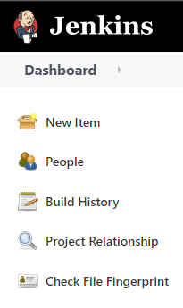

1. Enter an item name and choose pipeline then hit ok.

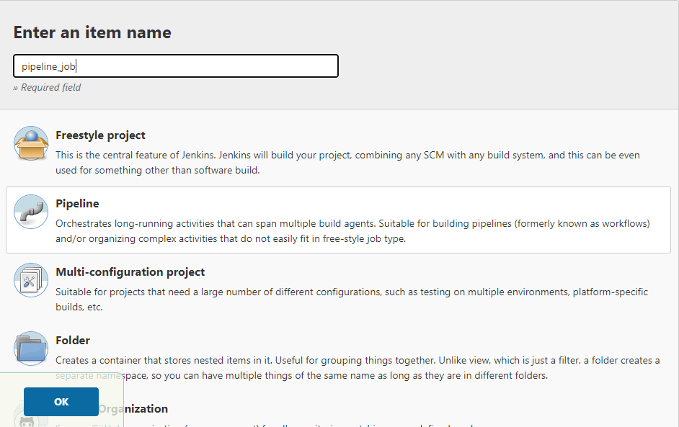

1. In general section choose discard old build.

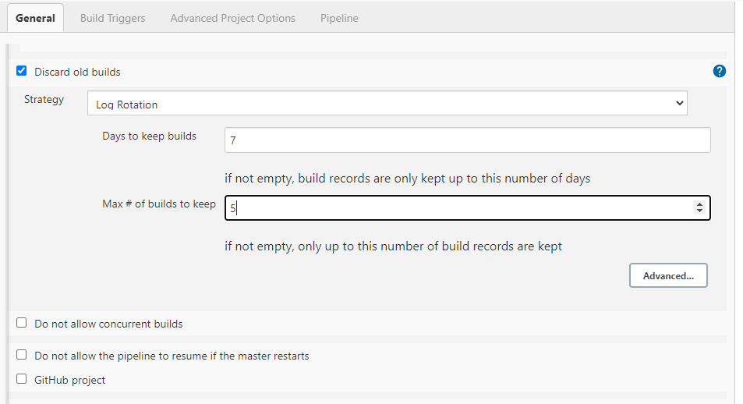

1. In build section choose GitHub hook for continuous integration between github and Jenkins.

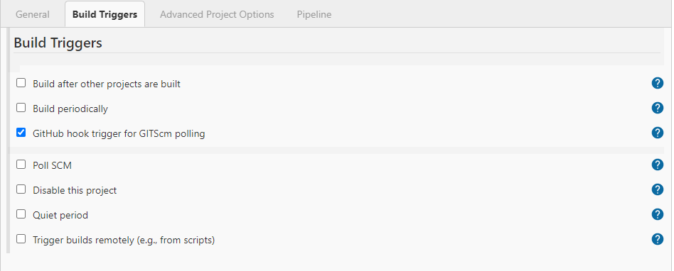

1. Generate Declarative Pipeline Like below using Pipeline Syntax.

